EU4ALL Moodle Component

User Model, Metadata Repository and Content Personalisation Moodle implementations



Deliverable:
Work Package:
Partners: | IPL
Workpackage
Task | T6.4.1 Set-up and implementation of the EU4ALL framework in further institutions
Date of delivery | Contractual |  | Actual
Code name | IPL-EU4ALL_moodle_implementation.odt |  | Version 1.1.229
Type of deliverable | Report
Security
(distribution level)
Contributors | Catarina Maximiano (IPL), Vítor Rodrigues (IPL)
Authors (Partner) | Cláudio Esperança (IPL)
Contact Person
WP/Task responsible | IPL
EC Project Officer
Abstract | This document discusses the installation steps for the EU4ALL Moodle component developed by IPL.
Keywords List | EU4ALL, Moodle, IPL, User model, Metadata repository, Content personalization
EU4ALL Project Coordinator: Lydia Montandon (Atos Origin)
Tel: +34 91214 8616; fax: +34 91754 3252; mobile: +34 680 647 915
email: lydia.montandon@atosorigin.com

Table of Contents
1 Introduction 6
2 Requirements 7
2.1 Hardware requirements 7
2.2 Software requirements 7
2.2.1 Server software requirements 7
2.2.2 Client software requirements 7
2.3 Skills requirements 8
3 Module description 9
3.1 EU4ALL local plugin 9
3.2 Course activity 10
3.3 Course format 10
3.4 Moodle capabilities 10
4 Installation steps 12

List of Figures
Figure 1: Module files copy 12
Figure 2: Successful installation screen 13
Figure 3: Remote services information 14

List of abbreviations
EU4ALL European Unified Approach for Accessible Lifelong Learning
LMS Learning Management System
IPL Instituto Politécnico de Leiria (Polytechnic Institute of Leiria)
UM User Model
CP Content Personalization
MR Metadata Repository
PHP PHP Hypertext Preprocessor
LAMP – Linux Apache MySQL PHP

Introduction
The aim of this document is to describe the minimum requirements, installation steps and a general overview of the EU4ALL Moodle components developed by IPL for the project.

Requirements
This module was developed over a LAMP environment using Moodle 2.0.1 and should work on this environment. Some more specific requirements are presented below.

Hardware requirements
There are no specific hardware requirements for this module in addition to those required for Moodle 2 and these can be found at the following address http://docs.moodle.org/en/Installing_Moodle#Hardware.

Software requirements
In general, this module has the same software requirements than Moodle 2, plus some specifics. This requirements are available at http://docs.moodle.org/en/Moodle_2.0_release_notes#System_requirements.

Server software requirements
- A workable installation of Moodle 2
- PHP soap client extension is required for the module to function properly
- A system account with file system write permissions to copy the module files to the destination system
- Network access to the EU4ALL service endpoints is also required

Client software requirements
Any standards supporting browser should work without any major problems. We have used Mozilla Firefox 3+ and Google Chrome 5+ on our testing, but Microsoft Internet Explorer 8+, Opera 9+, Safari 3+, should work too.

Skills requirements
There are some skill recommendations to successfully install this module on a Moodle instance:
- Knowledge about file system privileges on the destination operating system and how to change them
- Knowledge about installation of extensions and plugins within Moodle
- Some knowledge about Moodle Capabilities and Roles is also recommend

Module description
The EU4ALL Moodle module consists on three base components: a local plugin, a course format and a course activity.

EU4ALL local plugin
This is the base component of the module and contains the libraries to communicate with the EU4ALL repositories. The source files can be found on the :
[MOODLEROOT/local/eu4all
- version.php – specify the version of the component and the minimum version Moodle required.
- settings.php – create the site administration menu items for the module configuration.
- lib.php – common library file for the plugin which also and the menu entries on the user profile the set the EU4ALL user accessibility preferences.
- db/access.php – define the capabilities (permissions roles) for the plugin. For more information please go to the chapter 3.4.
- db/events.php – define the events that the plugin is able to handle, like the user account creation, deletion of adaptable resource, etc.
- db/install.php and db/upgrade.php – define database install and upgrade instructions.
- lang – folder that contain the plugin localization files.
- pages – contains the plugin pages and forms to set the module settings
- lib – contains the umlib.php (user model library), mrlib.php (metadata repository library), cplib.php (content personalization library) and auxiliary files that define the core of the module.

Course activity
The adaptable plugin, a course activity used to associate the course resources, send that information to the EU4ALL metadata repository and retrieve the resource that should be presented to the user when requested, can be found on the folder. The structure of this component is very similar to the one used on the EU4ALL local plugin. The exception goes to the presence of the db/install.xml file, which contains the table definition with the resources relations used by this module.
[MOODLEROOT/mod/adaptable

Course format
Format is a Moodle component that specifies the internal structure of a course and how the course resources should appear. This component was used to hide all the course resources that were associated by an adaptable, and present only the adaptable resource. When an user click on a adaptable resource link, this component ask the EU4ALL which resource should be presented to the user.
The users with the capability are allowed to view all the resources (for editing purposes) and their relations.
format/adaptable:viewadaptables

Moodle capabilities
The Moodle capabilities are a smart way to control the permissions within a Moodle instance (more information about this is available on the Moodle documentation).
The module rely on this capabilities to allow or deny access to specific features such as:
- local/eu4all:configureplugin – Configure the EU4AL plugin settings which should only be enabled for site administrators
- local/eu4all:umviewownprofile – Allow an user or role to see his EU4ALL remote profile
- local/eu4all:umeditownprofile – Allow an user or role to set his EU4ALL remote profile
- format/adaptable:viewadaptables – Allow an user or role to see the the resources relations

Installation steps
- Copy the contents of the [MOODLEROOT] directory to the root directory of a existent Moodle installation. This will merge the module content files with Moodle (if it's the first installation, no file should be replaced). When all the module contents are copied, check the file system read privileges by the HTTP daemon (the files should be readable by this service for the module to work).
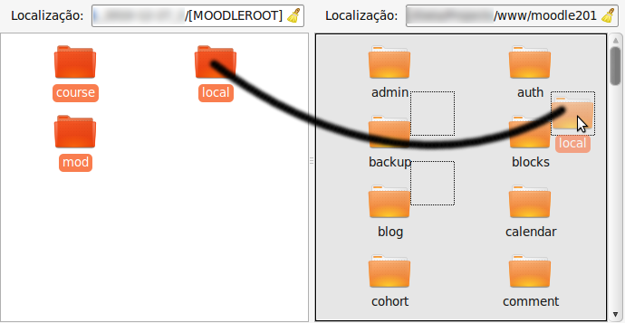Figure 1: Module files copy

- As a site administrator, click on to install and follow the wizard steps to install all the module components. In the end you should see a success message for each installed component.
Site administration->Notifications
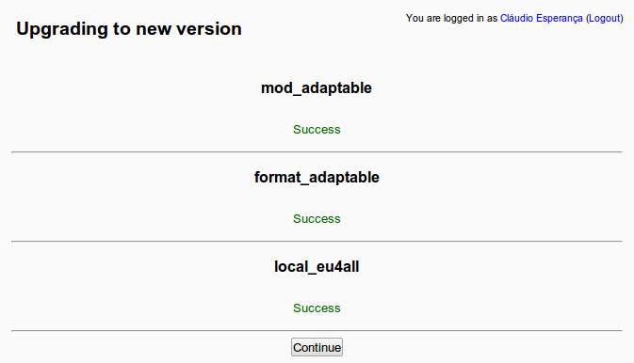Figure 2: Successful installation screen

- Now the module should be configured. Go to and define each setting accordingly. It's strongly recommended the definition of Manager reference and Resource prefix settings for the ones used on your institution. Save the changes and refresh this page one more time to verify if the system can communicate with the EU4ALL services.
Site administration->EU4ALL->Configuration
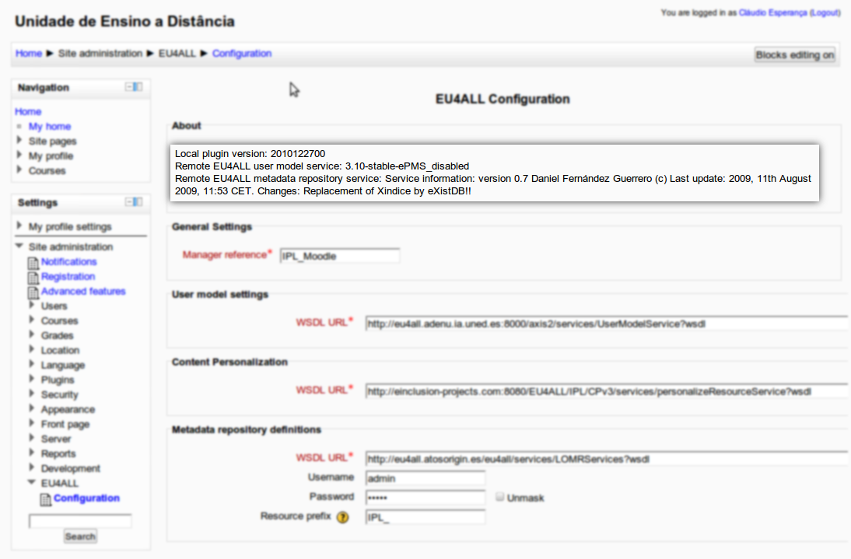Figure 3: Remote services information
The system is now ready to be used by the users as described on the technical user manual.

